**Git Repository Creation Steps**

1. Open GitHub in the web browser.

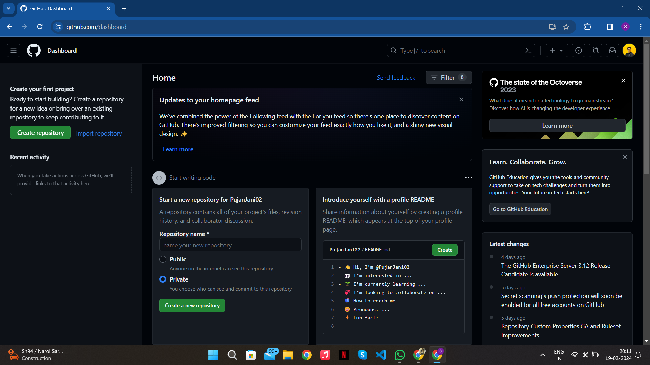

1. Click on the ‘+’ icon on the right side of the navigation bar. Drop down menu will be open.

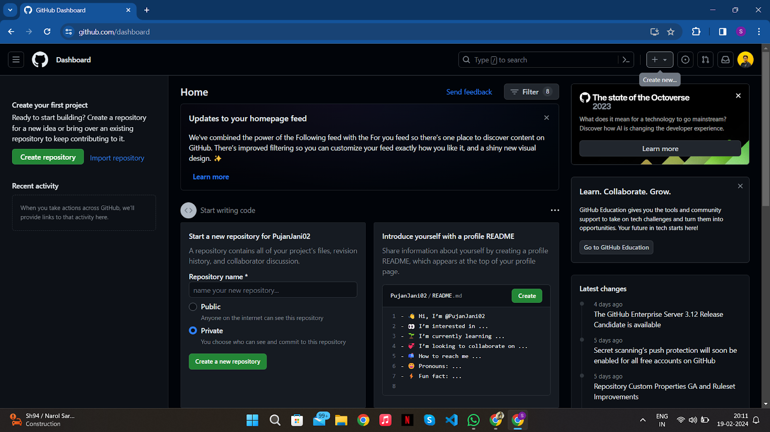

1. Select ‘New Repository’ from the drop down menu.

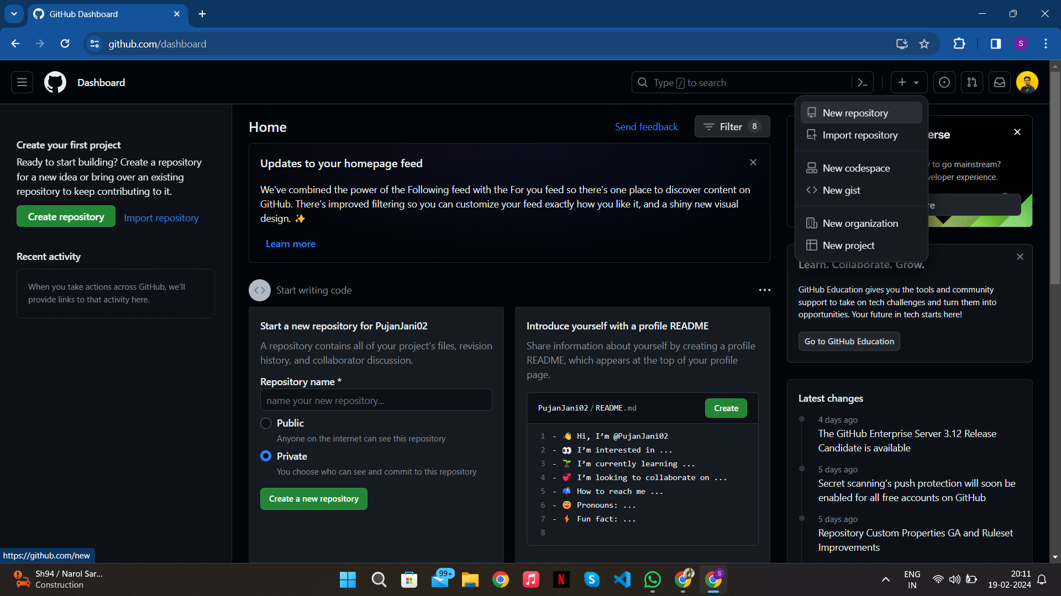

1. New page will be open.

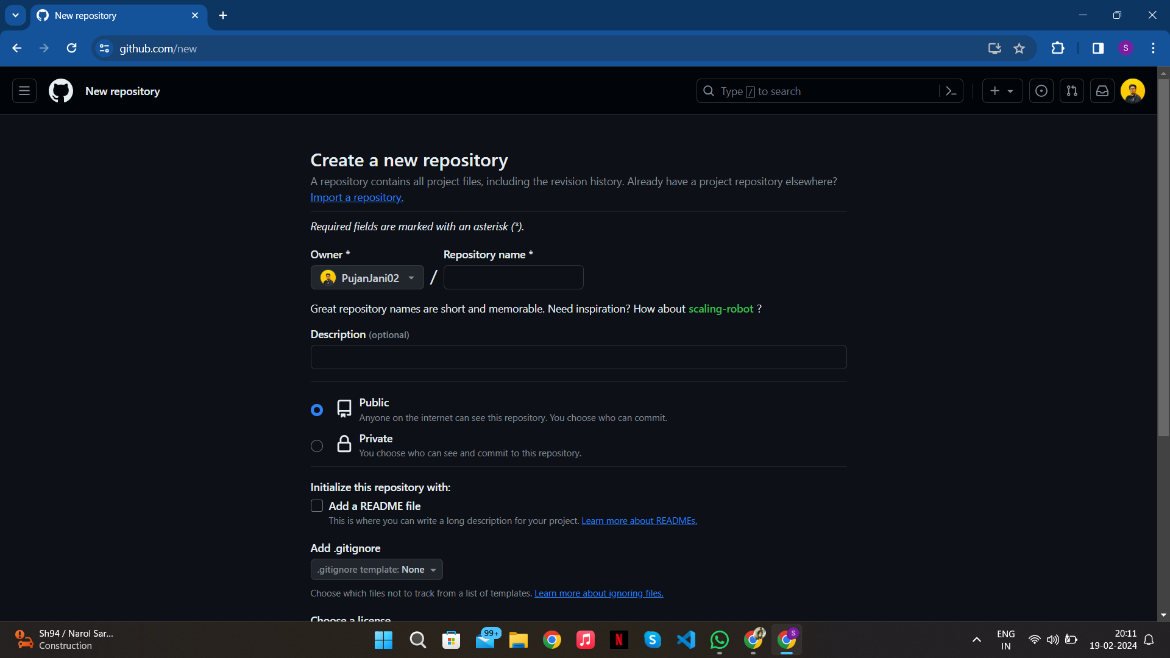

1. Enter Repository name (Here enrollment no), description (optional) and choose repository visibility

either public or private.

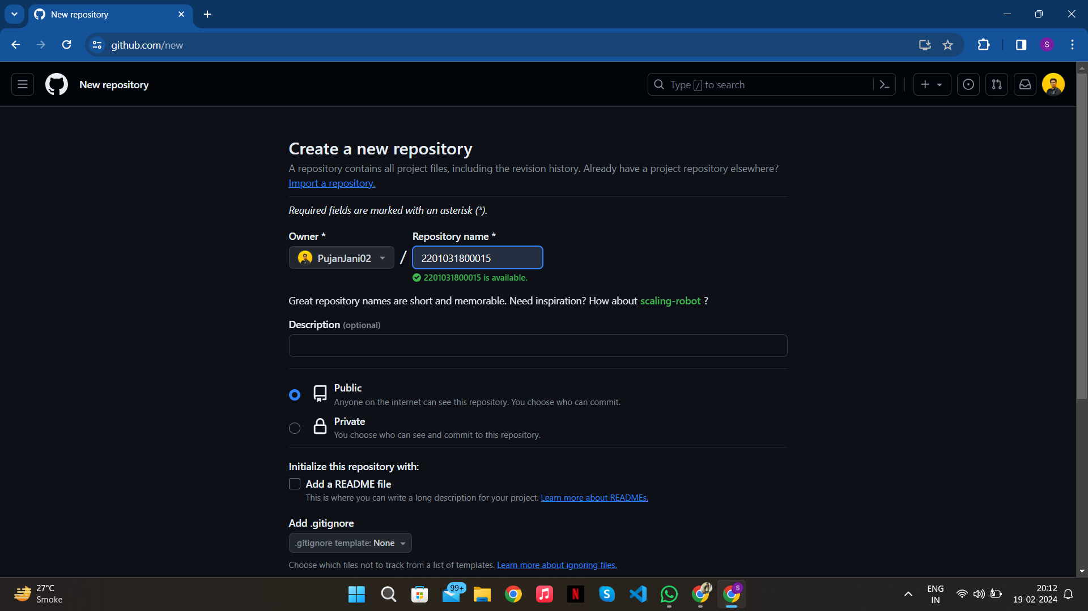

1. Click on the ‘Create repository’ button at the bottom to create a new repository.

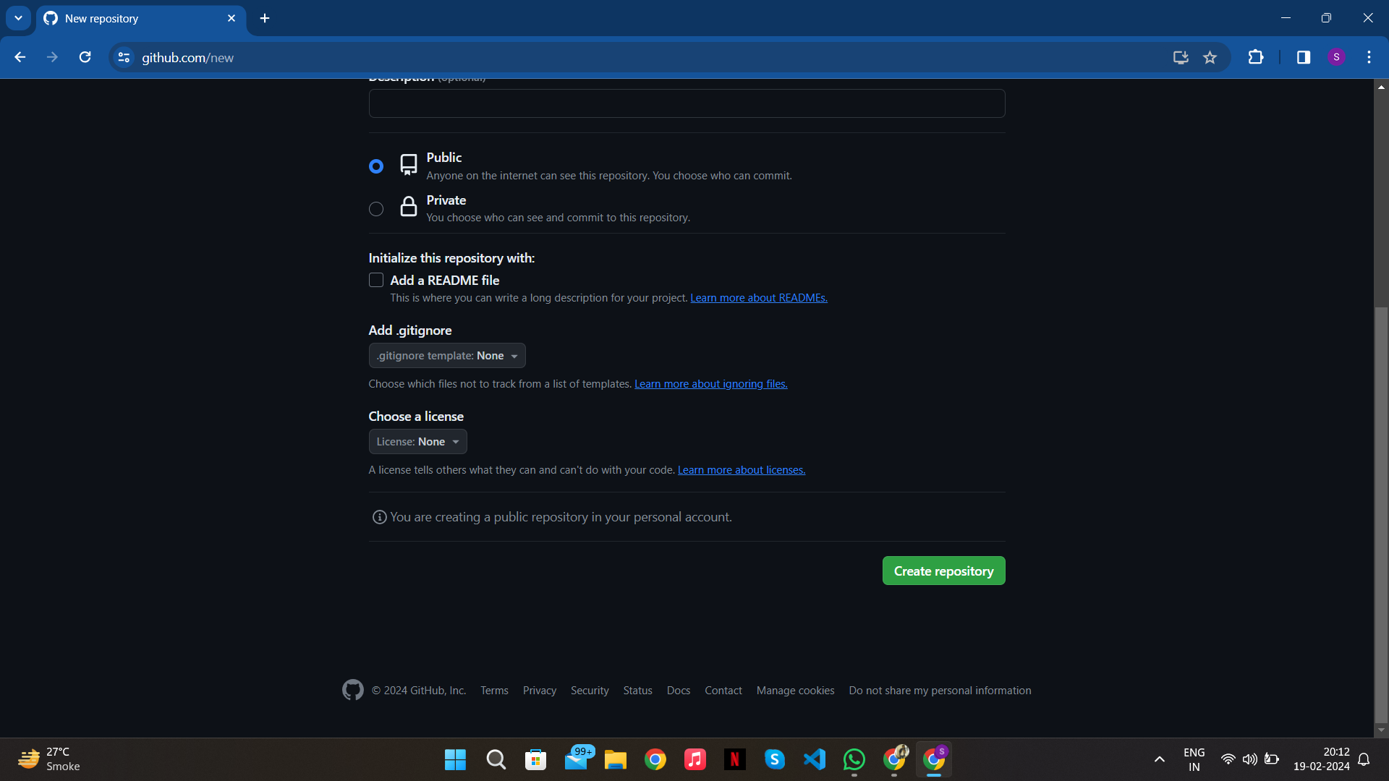

1. Once the repository is created, you'll be redirected to its page.

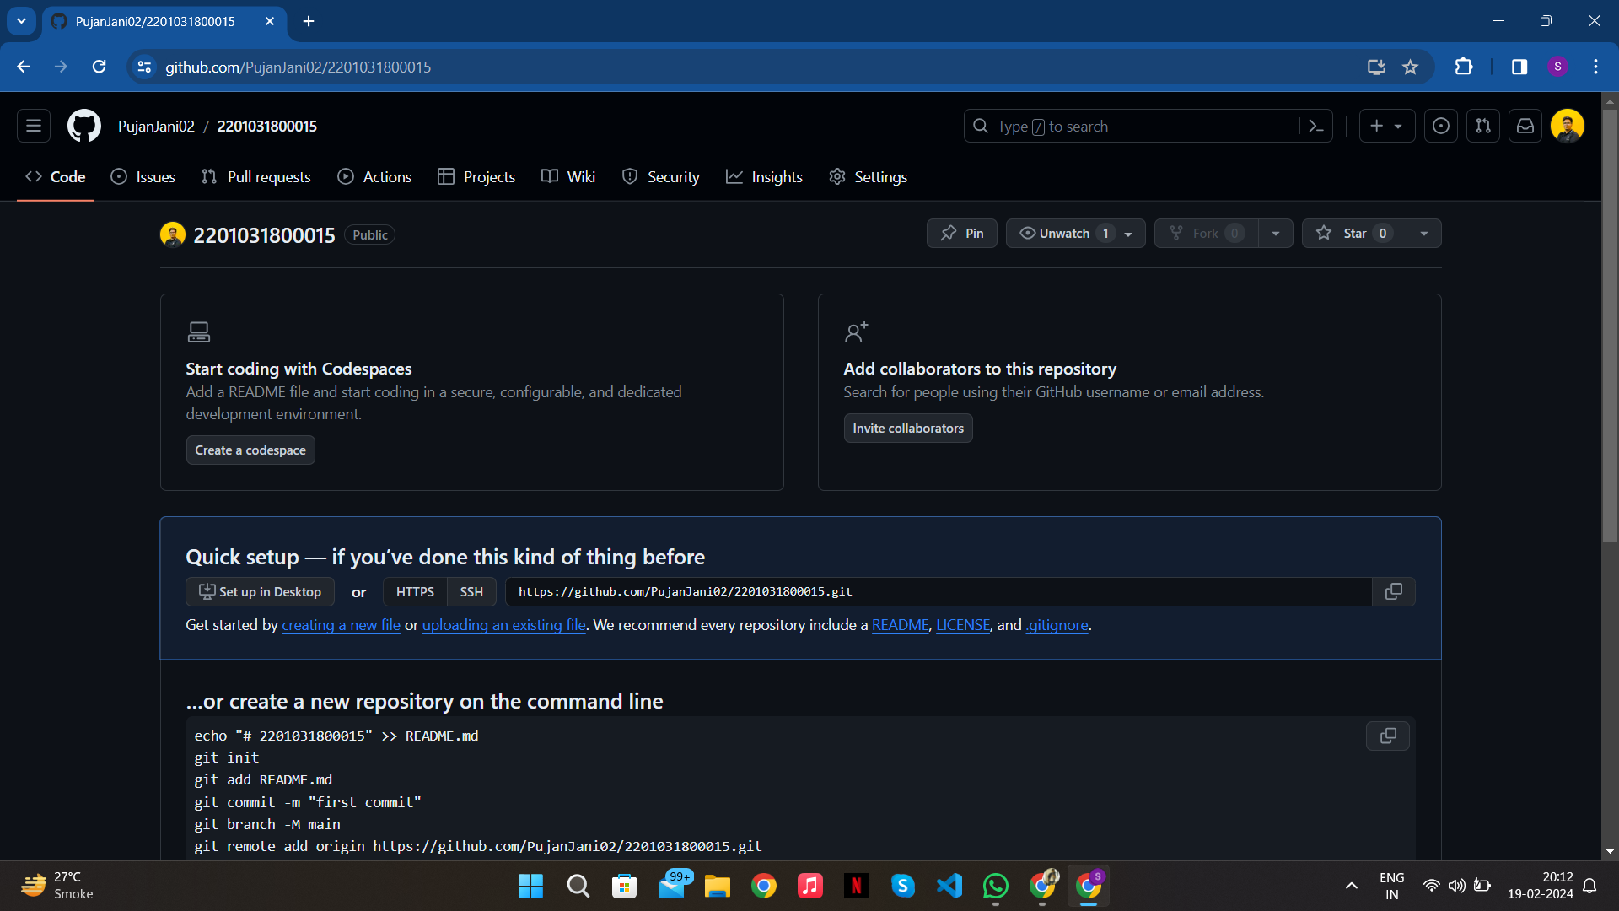

1. Open GitHub Desktop.

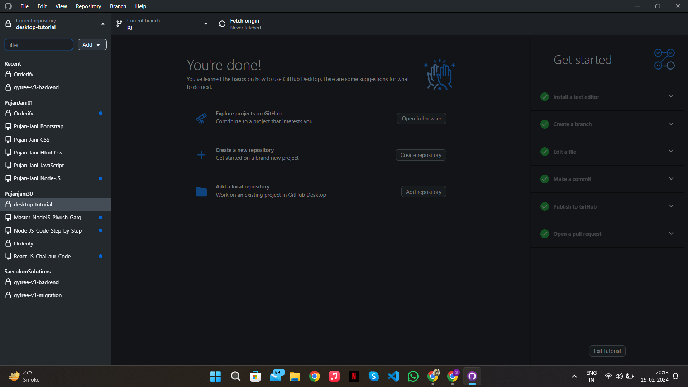

1. Click on the ‘Add’ button at the top-left panel. Drop down menu will be open and select ‘Clone Repository’ from the drop down menu.

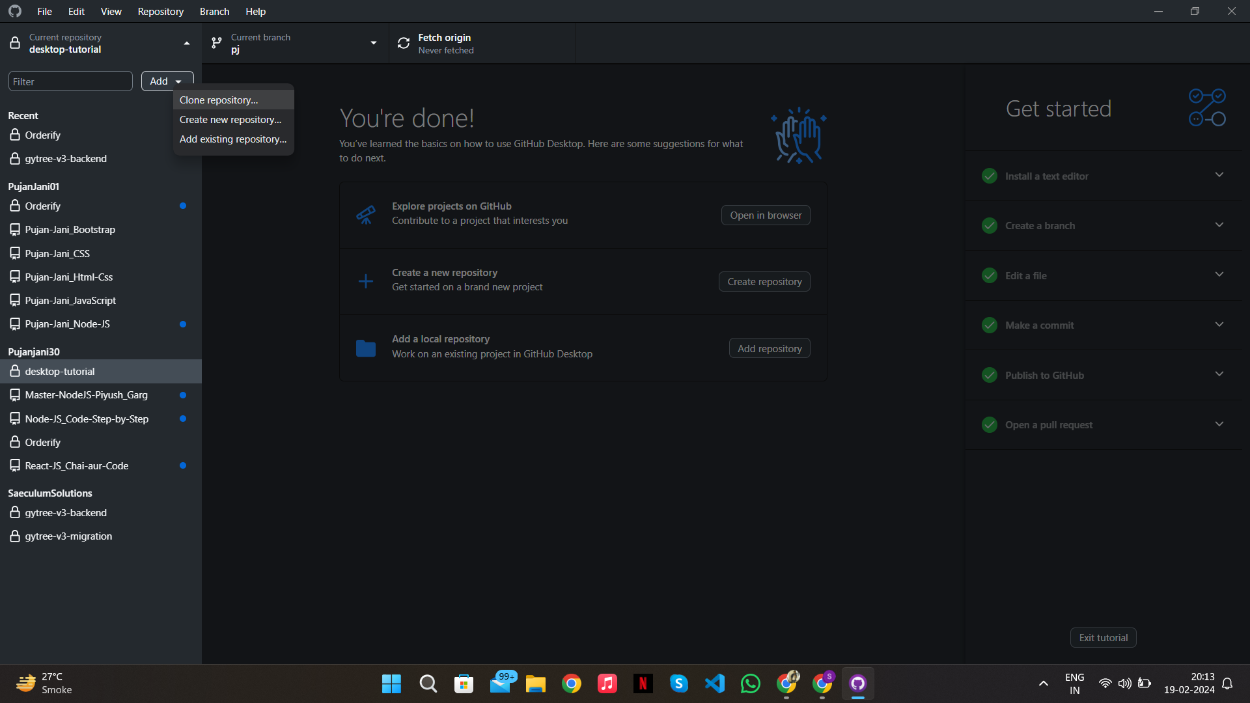

1. Modal box will be open.

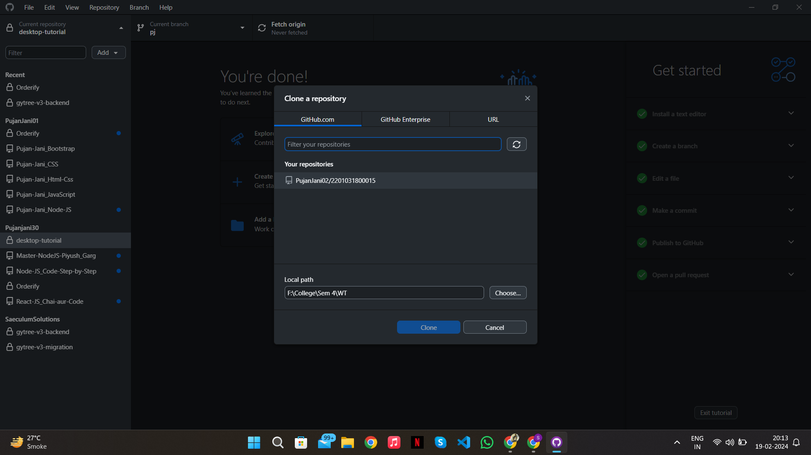

1. Select the repository to clone and set the local path. At last, Click on ‘Clone’ button.

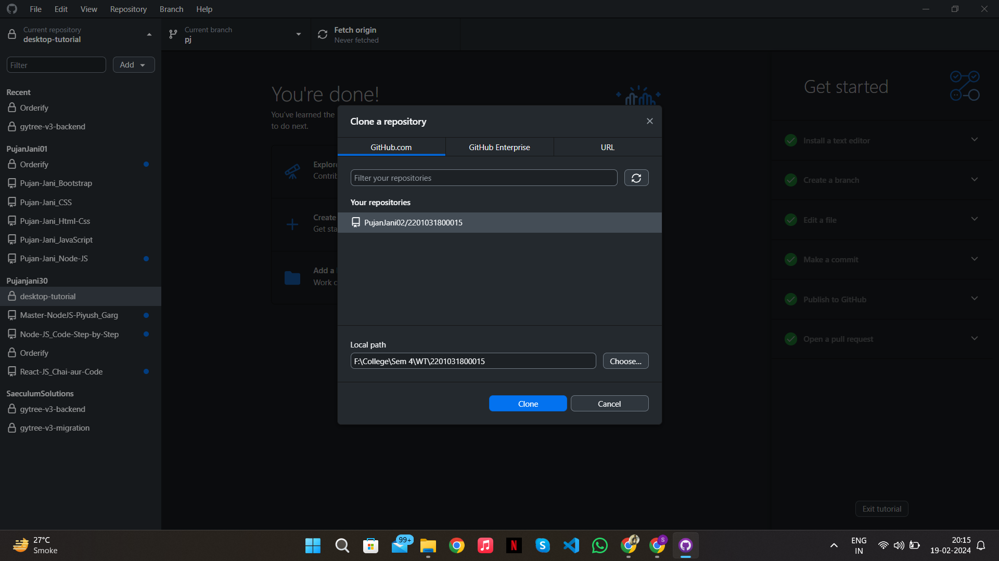

1. Open the repository in File Explorer and create two folders with the names Assignment_1 and Assignment_2 respectively.

